SMDC opens Now Residences Showroom and Office in Pampanga

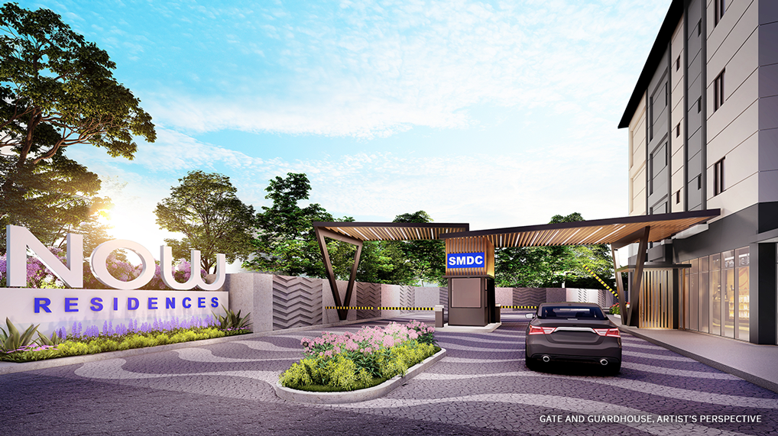
Masterfully-designed, future-ready, and optimized for progress, Now Residences is a gated, mid-rise residential garden community that offers a glimpse into the future of real estate. The development sits in one of the most sought-after real estate investment hotspots in the country — propelled by world-class infrastructure developments such as the Clark International Airport, and the Pampanga Megalopolis Plan that eyes the province as the business and financial center of Northern Luzon and a counter-magnet to Metro Manila.
A testament to the promise of the development, the Now Residences Showroom and Office offers a preview to the luxurious, sustainable lifestyle that awaits for more Filipinos, and features model units for viewing.
To know more about SMDC’s Now Residences, visit manilacondonetwork.com

